Asanačná s. r. o.

Záhumenská 49, 900 31 Stupava

IČO: 44 054 025 IČ DPH: SK2022587578

Pest Control - Professional and thorough protection against pests and infestation

Pest control, disinfection and gas fumigation, sales of pest control products
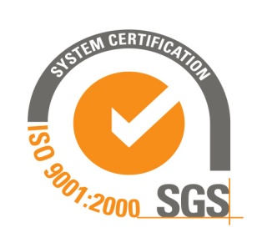
Contacts:
Miroslav Tomkovič tel. 0902 900 801
Anna Tomkovičová tel. 0902 900 800
e-mail: info@asanacna.sk
web: www.asanacna.sk

Services:
Rodent control
- rodent liquidation (mice, rats,..)
Disinfection
- elimination of microorganism and bacteria
Infestation control
- insect termination (cockroaches, bedbugs, mosquitoes, flies,...)
Fumigation and gassing
- termination of insects, rodents, treatments of pallets and granaries, ...

Asanacna s.r.o. foremost believes in using effective, high quality products for the extermination of pests. We do not believe in using low cost alternatives that require repeated treatments of the problem due to their infectivity, costing the client more money in the long run. Our staff has extensive experience, which is equally important in the successful control and elimination of pests.
Our firm emphasizes quality and not quantity. Our found, Mr. Eduard Veselý has operated in this business since 1983 as a specialist in rodent and insect control, disinfection and gas fumigation. The current owner, Miroslav Tomkovič worked together with Mr. Veselý and is certified specialist since 1992.

